LeWoS
December 13, 2022
Title A universal leaf-wood classification method to facilitate the 3D modelling of large tropical trees using terrestrial LiDAR
Version 1.0.2
Date 2019-12-04
Author Di Wang
Overview LeWoS is implemented at 100 % on MatLAB, and it has a MIT-License and its code is available on github. Using LeWoS it is mainly possible to estimate biomass and distinguish between leaves and wood through close-range point clouds. Documentation about 'LeWoS' is described in Wang et al. (2020).
URL github repository: https://github.com/dwang520/LeWoS
Wang et al. (2020):https://doi.org/10.1111/2041-210X.13342
Sostware requirements It mandatory to have a MATLAB license.

Installation 2
Functions 3
Turn on the GUI 3
Load Point Cloud 3
Run segmentation 3

Installation
LeWos is on github, so accessing through this link https://github.com/dwang520/LeWoS the complete repository must be download as a zip (see Figure 1). Once downloaded must be decompress in our computer.
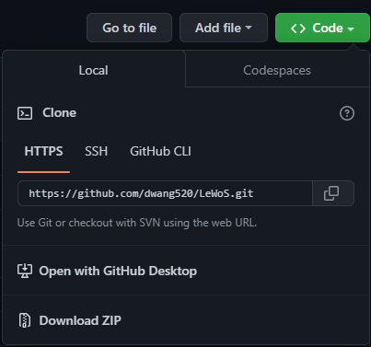
Figure 1.Dowloading LeWoS repository as a zip.
From MATLAB interface it necessary to set the path where LeWoS is stored. As it is shown on Figure 2, by clipping first on set path (environment tools) and then pressing on add folder button the path will be set.
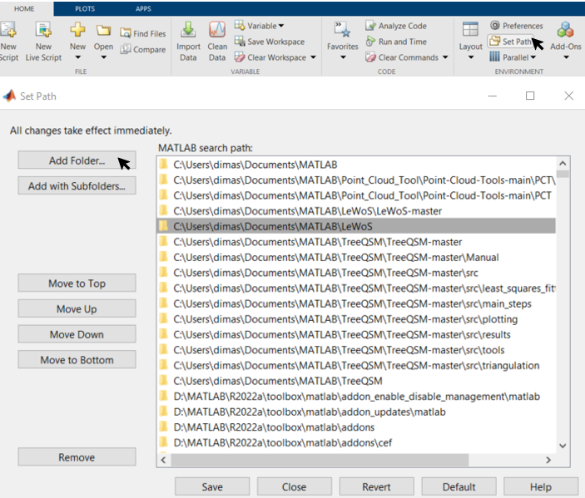
Figure 2. Setting LeWoS path on MATLAB.

Functions
LeWoS has a simple but useful graphic user interface (GUI) where the main available function is segmentate the point cloud distinguishing between leaves and wooden parts. Table 1 lists the software functions and their outputs, followed by a description of how to use them.
Table 1.Main functions and its outputs.
Interface fucntions | Output parameters
Load Point cloud | Load a close-range point cloud
Run segmentation | Classified cloud disntiguishing between leaves and wood
Export results | Classified cloud as a .txt file

Turn on the GUI
To turn on LeWoS GUI just type “LeWoS_RS” on MATLAB command window, then a pop-up window will appear automatically.

Load Point Cloud
To load a point cloud file just clip on “Load Point Cloud” button, and then on “Show” to plot it (Figure 3).
These formats are supported:.las; .mat; .xyz; .txt; .ply; .pcd (on github documentation it is recommended to use generic formats such as las, ply, and pcd). Whiler working with ASCII point clouds, the space must be de delimiter and the file must not have a header.
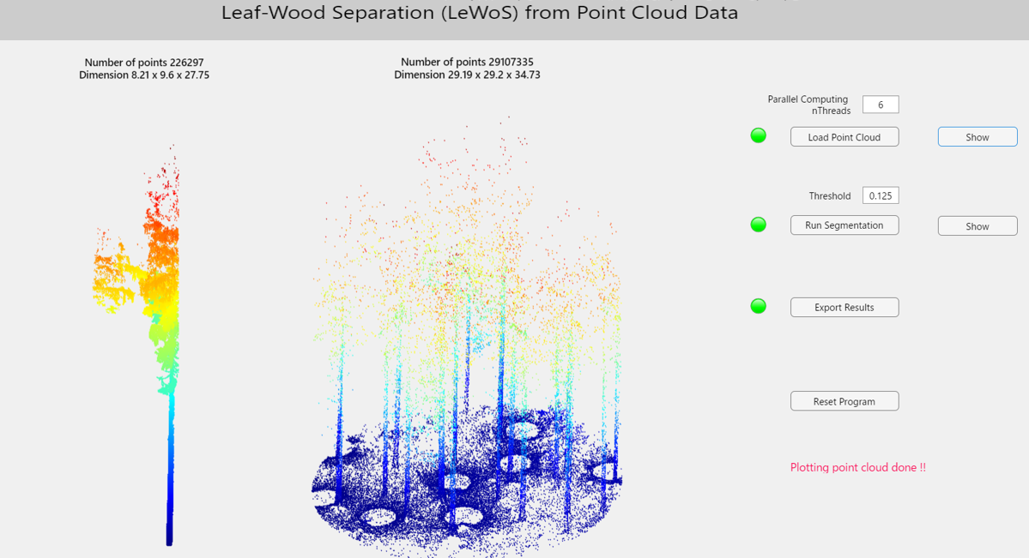
Figure 3. On the left a tree cloud is plotted; on the right a plot point cloud one.

Run segmentation
Once the point cloud is loaded, clip on “Run Segmentation” (using default values for threshold is a recommendation) and the segmentation will be executed. Figure 4 shows the cloud once classified.
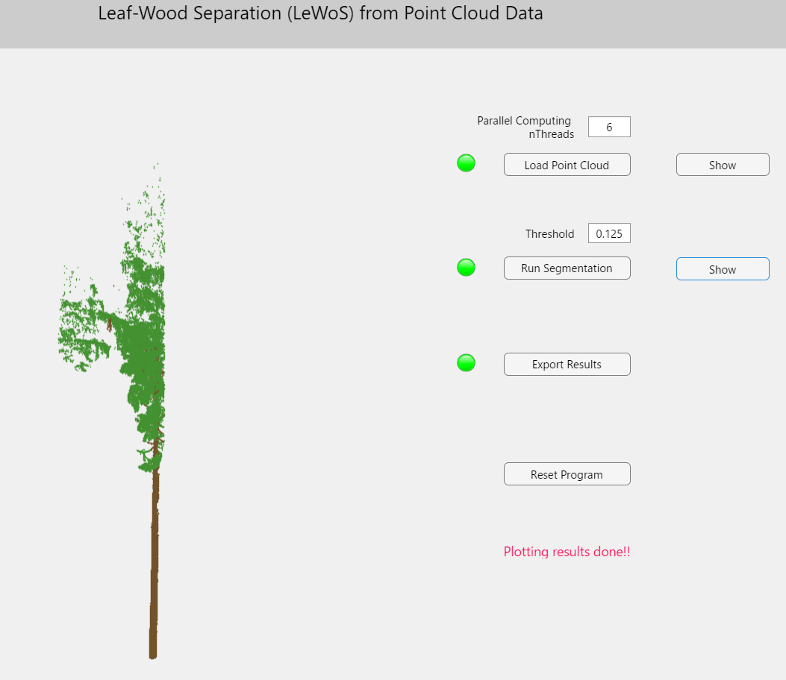
Figure 4. Representation of the classified cloud (green:leaves and brown:wood).

Export results
Finally, the classified cloud could be exported as a .txt file by clipping on “Export results” button.

