FSCT (Forest Structure Complexity Tool)
URL: https://github.com/SKrisanski/FSCT
Date: 18 September 2022
Author: Sean krisanski
Description: this tool was developed to do automatic plot scale measurements from high resolution data such as Terrestrial Laser Scanner (TLS), Mobile Laser Scanner (MLS), Terrestrial Photogrammetry, above or below canopy UAS photogrammetry or similar. The segmentation with Aerial Laser scanning (ALS) is still at border line. There is one thing to notice is if the point cloud is not with high resolution, then the segmentation model will label the stems as vegetation points.

The output of this tool is presented at the YouTube channel: https://youtu.be/rej5Bu57AqM

- Installation: the installation process is very easy, however you might encountered with a few errors based on the configuration of you computer. The instructions will also work for the Windows 10 with 16 GB or 32 GB RAM but the processing time will vary between 7 to 8 hrs. if you are processing point cloud data of 2 GB size. However, the basic setup for this tool is as below:

CPU: Intel i9-10900K (overclocked to 4.99GHz all cores).
GPU: Nvidia Titan RTX (24 GB vRAM)
RAM: 128 GB DDR4 at 3200 MHz (If you run out of RAM, try increasing your page file size (Windows) or swap size (Linux))

You should also have Anaconda installed in your computer. Open the Anaconda command prompt and follow the command lines below:

cd PATH_TO_FSCT-MAIN_DIRECTORY
conda create --name YOUR_ENVIRONMENT_NAME_HERE python==3.9
conda activate YOUR_ENVIRONMENT_NAME_HERE
conda install pip
pip install -r requirements.txt

The requirements.txt file has all the required packages. However, there is a chance to get an error of Microsoft C++ build tool while building the hdbscan packages. So, you need to download or upgrade your Microsoft C++ build tool using this link: "Microsoft C++ Build Tools": https://visualstudio.microsoft.com/visual-cpp-build-tools/

The error could be something like this:
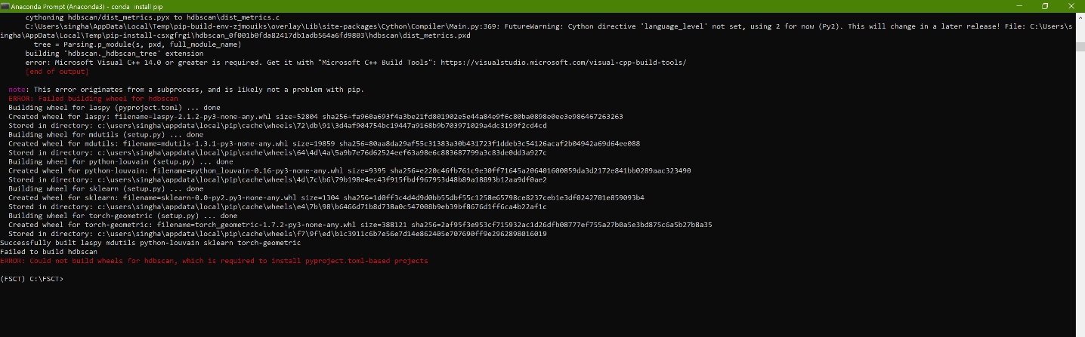

After installing the Microsoft C++ build tool, hopefully the installation will be successful, and you need to run the requirements.txt file again and it should not end with any error.

- How to use:
Open Anaconda navigator and launch spyder. Open the run.py file, which should be in the scripts folder of FCST main folder.
Run the run.py file. This will asl you for input of .las files. f all goes well; you will have a new directory in the same location as the “. las" file/s you selected and once complete, this will contain the following outputs.

