AID-FOREST
December 13, 2022
Title Artificial Intelligence for Digital Forest
Version 1.0.25 (406)
Date 2020-04-08
Author DIELMO 3D
Overview AID-FOREST is a commercial software developed by DIELMO 3D. Which main objective is to obtain automatically forest parameters through mobile terrestrial laser scanner data.
URL https://dielmo.com/es/blog/aid-forest-articulo-cientifico-en-el-que-participa-dielmo-3d/
Software requirements No requirements
Installation 2
Functions 2
How to use it 2
Input files paths 3
Outputs parametrization 4
Configuration menu 4

Installation
There is a executable file to install the software. Every time the software is used, the computer will be checked for licences. If there is not a license you have to request one, as show Figure 1 clipping on “Request license” button a key will appear, and you have to send it to dielmo@dielmo.com to activate it.
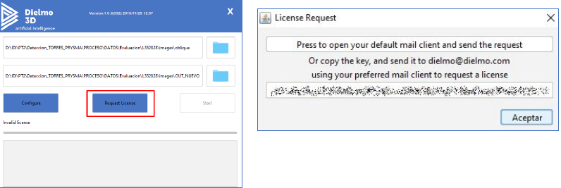
Figure 1.AID-FOREST activation.

Functions
AID-FOREST has a simple Graphic User Interface (GUI) and also has a predefined workflow. This is conformed by eleven steps: LAS files read; Digital Terrain Model (DMT) creation; Digital Surface Model (DSM) creation; height normalization; point cloud rasterized at different heights; elements detection; boxes detections shapefile creation; tree positioning; tree detections shapefile creation; dasometric parameters estimation at plot level; dasometric parameters estimation at stand level. At the end of the workflow the outputs that will be generated are collected on Table 1.
Table 1.Main functions and its outputs.
Output parameters | Description
Boxes detections | Detections made on each tree at different heights
Tree detections | Tree position and dendrometry parameters
Plot level report | Plot information and dasometric parameters with the hectare as the unit of reference
Compartment level report | Dasometric parameters at stand level

How to use it

AID-FOREST GUI is shown on Figure 2, it can be divided into five sections: 1. Input files paths; 2. Output parametrization; 3. Configuration menu; 4: Start button; and 5. Process registration.
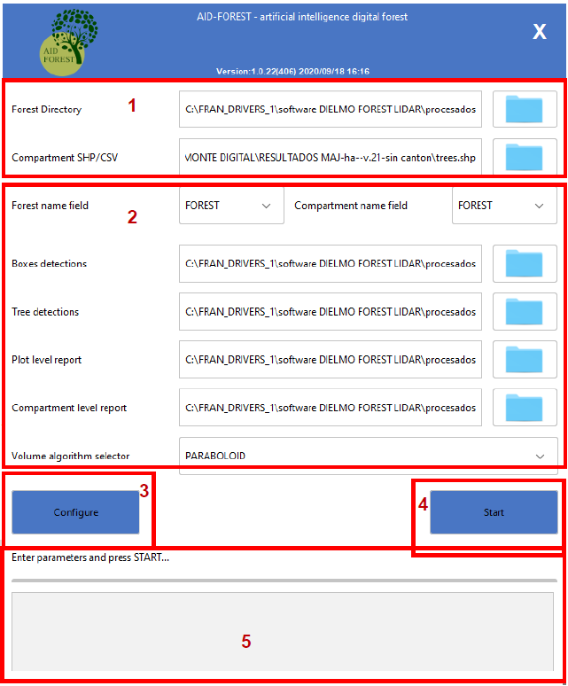
Figure 2. AID-FOREST GUI appearance.

Input files paths
A certain structure of input files folders must be set up (Bosque_1>Canton_1>Plot_1.las but also shown at Figure 3) for working properly. Using this structure will allow to work with different stands point clouds.
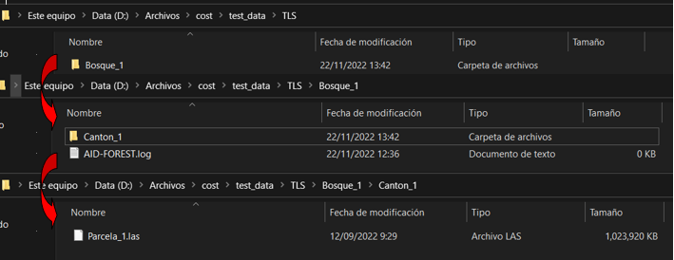
Figure 3. Structure of input files folders.
A shapefile with the limit of the plot or the stand is needed. This spatial database must have two fields (FOREST and CANTON), as it is shown on Table 2 the field must be completed with the names of the folders indicated before (when input files paths were configured). Note that these conditions must be met, otherwise the software will not work.
Table 2.Spatial data base with the stand limits.
FOREST | CANTON
Bosque_1 | Canton_1

Outputs parametrization
Forest name field and Compartment name field are drop-down menus that reads the fields of the shapefile with the limit of the stand. The first one is related to the complete forest and the second one to stand.
Then it is necessary to define the paths where the output will be created: boxes detected and trees detected as shapefile; and stand and compartment dasometric variables report as a .csv files.
We have to set up the volume algorithm, indicating in this case which trunk shape have to be considered while computing: cone; cylinder; paraboloid; or neiloid.

Configuration menu
Figure 4 shows the configuration menu, and each one of its parameters are explained below.
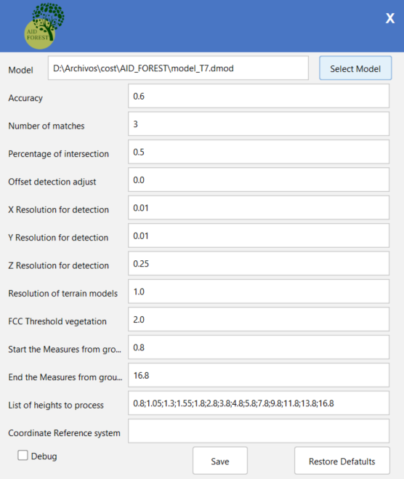
Figure 4. Configuration menu.
AID-FOREST has a implemented a model to detect trees (model_T7.dmod) which is the result of training a neuronal network. This model can be adjusted to each situation by modifying the parameters to obtain the best result.
The adjustable parameters are the following:
- Accuracy (this is related to probability of detected section belongs to a tree).
- Number of matches (this is the minimum number of planimetrically overlapping square sections of the tree to be considered as a single object).
- Percentage of intersection (this is the minimum percentage of intersection between square sections detected to be considered part of the same tree).
- Offset detection adjust (The detection of each section is framed on a two-side box, this box must fit the point cloud. So the size of this box must be set).
- X resolution for detection (spatial resolution of the x-axis height raster)
- Y resolution for detection (spatial resolution of the y-axis height raster)
- Z resoluction for detection (X resolution for detection (spatial resolution of the z-axis height raster; this parameter refers to height of the slice projected on the raster).
- Resolution of the terrain models (spatial resolutions of the DTM and DSM).
- Vegetation cover fraction threshold (indicate the height or heights where the vegetation cover fraction has to be calculated).
- Start the measures from ground (height where detection has to start).
- End of the measures from ground (height where detection has to end).
- List of heights to process (list of the heights where assessments must be carry out; height values must be multiples of Z resolution for detection).
- Coordinates Reference system (no need to indicate if there is no geo-referenced data).

Description of the outputs

Boxes detection
In each of the trees this function detects sections at different height along the trunk and save them on a shapefile (Figure 5 shows how this output looks if it is opened on any geographical information system). This shapefile also has an attribute table with the fields that are recompiled on Table 3.
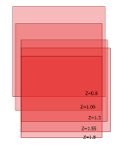
Figure 5. Boxes detection (figure obtained from AID-FOREST user guide)
Table 3. Fields or parameters collected in the detected boxes table.
Field or parameter | Description
ID_GROUP | It can shows three values: -2 discared detection; -1 detection that does not comply the minimun requirements; and a number associated at any of the detected trees.
Z | Height where the detection has been done
FCC | Vegetation cover of the plot
SCORE | This fields refers to how good is the detection (0-1)
CLASS | Class which the object belongs (1: trunk)
D1_WITH | East-West diameter
D2_WITH | North-South diameter
MATCHES | Number of the sections detected in each tree
AREA | Surface of the section (D1xD2)
FOREST | Name of the Forest
COMPARTMENT | Name of the stand/plot
PLOT | LAS file used

Tree detections
In this case, a shapefile with as many objects as trees were detected in the point cloud is created. Table 4 collects all the parameters calculated while detecting individual trees.
Table 4. Fields or parameters collected in the detected tree table.
Field or parameter | Description
FOREST | Name of the Forest
COMPARTMENT | Name of the stand/plot
PLOT | LAS file used
ID_TREE | Id for each tree
X | x-axis coordinate calculated from the centroid (at the lowest detection)
Y | y-axis coordinate calculated from the centroid (at the lowest detection)
NEAR_T | Id of the nearest tree
D_NEAR_T | Distance to the nearest tree
Ht | Tree height
H1v | Height of the first alive stem
Vt | Trunk volume estimation
ba | Basel surface at 1,3 m

Plot level report
This output consists in a csv file where different dasometric parameters refers to the plot are collected (Table 5)
Table 5. Fields collected in the plot level report.
Field or parameter | Description
FOREST | Name of the Forest
COMPARTMENT | Name of the stand/plot
PLOT | LAS file used
Plot size | Surface obtained from the sum of the pixels of the digital terrain model.
FCC | Vegetation cover at a certain height (there will be as many as requested heights)
n_plot | Number of tree in the plot
BA_plot | Basal area of the plot
Dg_plot | Mean quadratic diameter of the plot
Ht_plot | Height mean of the plot
Hd_plot | Dominant height
H1v_plot | Mean height of the first whorl
Vt_plot | sum of the volume of all trees on the plot
n_hec | same dasometric variables but referring to the hectare as a unit of area.
BA_ hec
Dg_ hec
Ht_ hec
Hd_ hec
H1v_ hec
Vt_hec

Compartment level report
This output consists in a csv file where different dasometric parameters refers to the comparment are collected (Table 6).
Table 6.Fields collected in the compartment level report.
Field or parameter | Description
FOREST | Name of the Forest
COMPARTMENT | Name of the stand/plot
PLOT | LAS file used
FCC | Mean vegetation cover fraction of all the plots.
N_avg_comt | Mean number of trees of all the plots
BA_avg_comt | Mean basal area of all the plots
Ht_avh_comt | Mean height of all the plots
Hd_avg_comt | Mean dominant height of all the plots
H1v_avg_comt | Mean height of the first whorl of all the plots
S-n_comt | Standard deviation of each dasometric variable
S-BA_comt
S-DBH_comt
S-Ht_comt
S-Hd_comt
S-H1v_comt
S-Vt_comt
E-n_comt | Sampling error (5% confidence inteval)
E-BA_comt
E-DBH_comt
E-Ht_comt
E-Hd_comt
E-H1v_comt
E-Vt_comt

